Spring 2013
Hilsman Middle School

Ecosystems and Invasive Species

Supply list: organism “role” cards and string

Lesson Outline:

1. Activity (10 min)
If the weather is nice, feel free to take students outside for this activity. Each student receives one organism “role” to play from a Georgia ecosystem. Have the students introduce their organism and its “role” to the rest of the group. Use string to connect each organism to the others that it helps or depends on (as written on the cards). This helps visualize all the connections within the ecosystem.

Discuss what each organism needs and how it depends on the others in the system. Could any organism live by itself? How would a change (i.e. extermination, infection, population growth) in one type of organism result in changes to others?

Invasion! Instructors will represent the invasive species. Introduce your organism and its impact on the ecosystem. The invasive species eliminates/outcompetes a native species-- that student must let go of his/her connections(strings) in the ecosystem.

What happens to the organisms that depended on the eliminated species? That the eliminated species needed? What else does the invasive species do? How is this ecosystem now different?

2. Discussion (10 min)
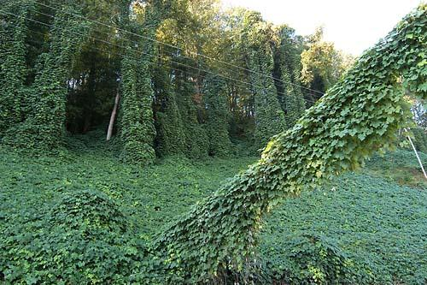
Discuss with the students the consequences of moving organisms around (bringing something new into our biome OR taking an organism out of its home). We humans do this on both large and small scales: individuals dump exotic pets or take plants home with them, and on a large scale we import species as game, crops, and ornamentals. Some invasive species they might be familiar with:
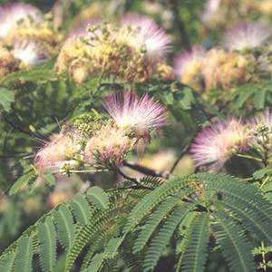
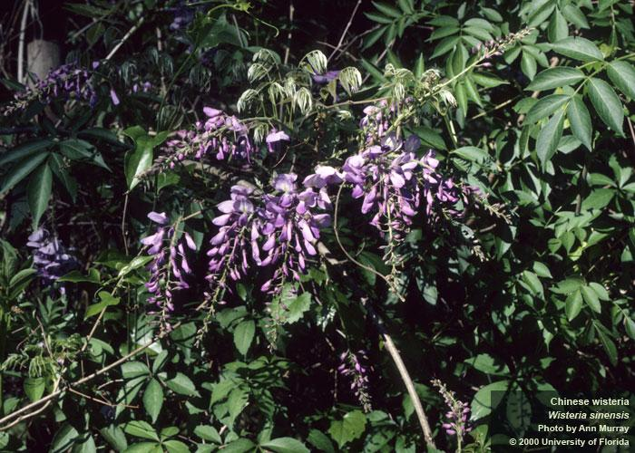
kudzu wisteria mimosa

fire ants
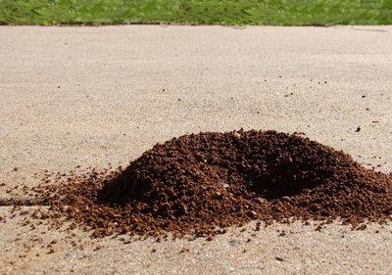
What happens when you take an organism out of it’s biome or natural habitat (i.e. a beetle, a box turtle, a plant you find on the side of the road)?
What happens when you bring a new organism to our biome (i.e. releasing an exotic fish into a pond)?

Note: There are plenty of subtleties to the issue, and an important one is that not all exotic (non-native) species are necessarily invasive (harmful to ecosystems). The idea here is to get the students to actually think about the potential consequences of introducing novel species.

Organism “role” cards

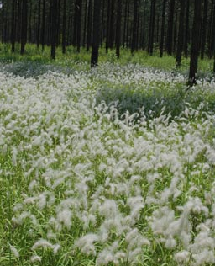
Cogongrass
Replaces understory plants like berry bush
Not good food for birds and squirrels
Rough edges hurt squirrels
Encourages very hot fires

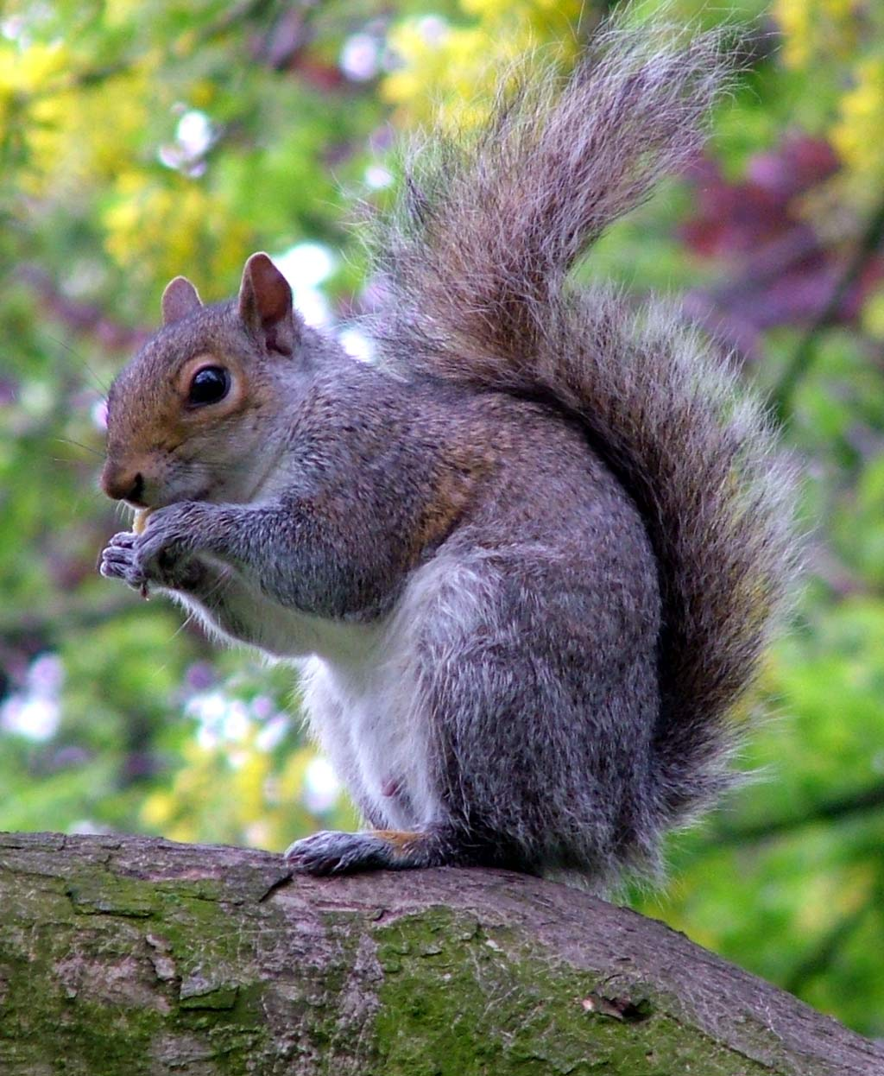
Squirrel
Eats nuts and seeds
Eaten by owl
Lives in trees

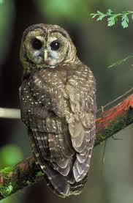
Owl
Eats squirrels and snakes
Lives in trees

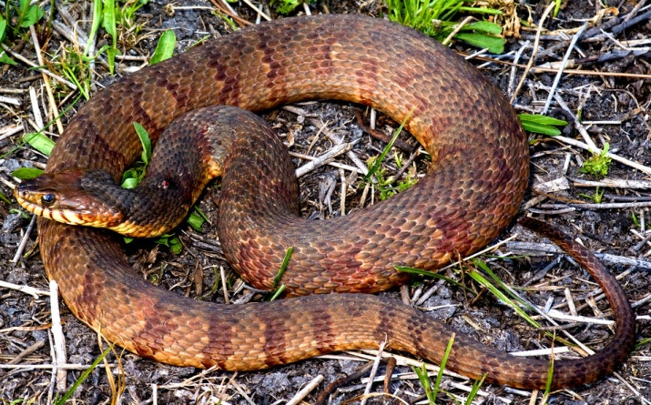
Snake
Eats birds
Eaten by owl
Hides from owl under berry bush

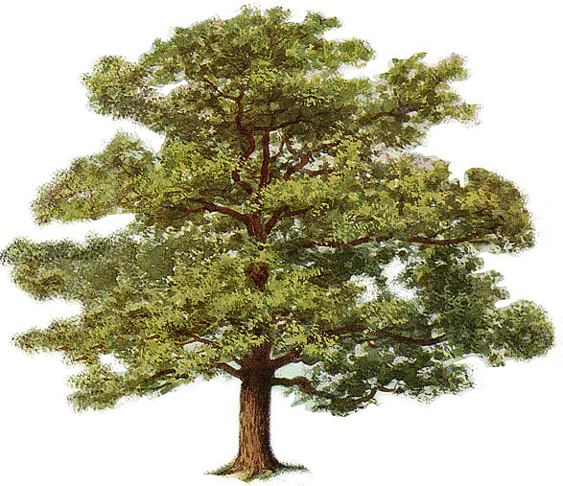
Oak tree
Seeds spread by squirrels
Killed by fire

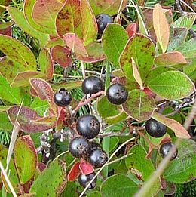
Berry bush
Killed by fire
Pollinated by insects
Seeds spread by songbirds

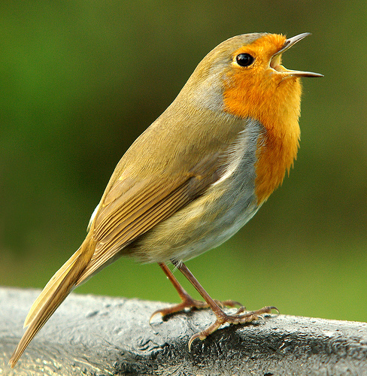
Songbirds
Eats berries and spreads seeds
Eats insects
Killed by snake
Lives in trees

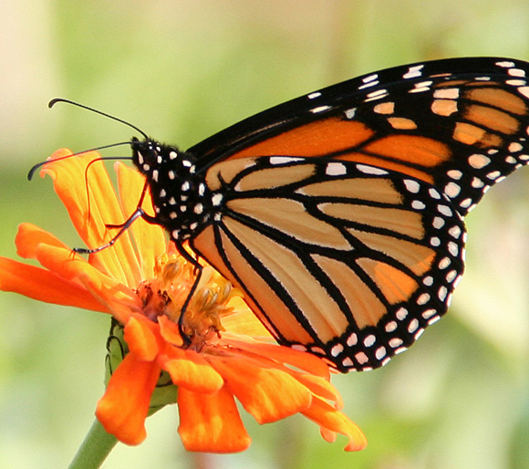
Insects
Pollinate berry bush
Eaten by birds
Live on understory plants

